***COMPUTER RECORD***

AMAN K

1.INPUT:

#Menu driven program to calculate area of rectangle,circle,square & triangle

from math import *

o = "Y"

while o in "Yy":

print("\nEnter corresponding data to calculate Area of",

"\n1.Rectangle\n2.Square\n3.Circle\n4.Triangle")

opt = input("\nYour choice:")

while opt not in "1234":

opt = input("Enter a valid data to continue:")

if opt == "1":

l = float(input("\nEnter Length of Rectangle:"))

b = float(input("Enter Breadth of Rectangle:"))

print("Area of Rectangle =",l*b)

elif opt == "2":

l = float(input("\nEnter Side Length of Square:"))

print("Area of Square:",l**2)

elif opt == "3":

l = float(input("\nEnter Radius of Circle:"))

print("Area of Circle:",pi*l**2)

elif opt == "4":

l = float(input("\nEnter Height of Triangle:"))

b = float(input("Enter Base of Triangle:"))

print("Area of Triangle:",l*b/2)

o = input("\nDo you wish to Continue(Y/y to continue):")

output:

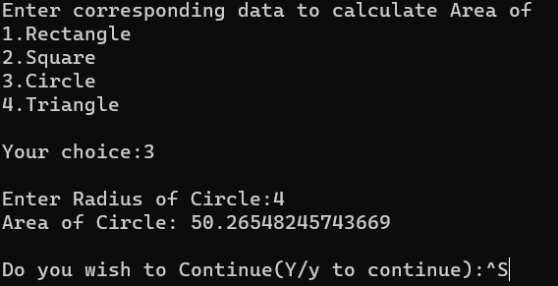

2.INPUT:

#Dictionary info OF EMPLOYEE name,designation&salary

emp = dict()

n = int(input("Enter number of entries:"))

for i in range(n):

name = input("Enter EMPLOYEE name:")

slr = float(input("Enter EMPLOYEE salary:"))

Dsn = input("Enter EMPLOYEE Designation:")

emp[name] = (slr, Dsn)

l = emp.keys()

print("\nName\t\t\tDesignation\t\t\tSalary")

for i in l:

print(i,"\t\t\t",emp[i][1],"\t\t\t",emp[i][0])

OUTPUT:

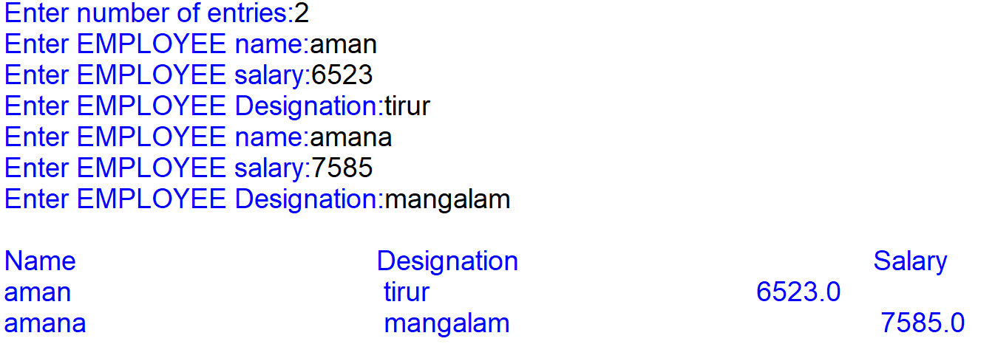

3.INPUT:

#factorial of a number using function

def fact(num):

num=num+1

fac=1

for i in range(1,num):

fac=fac*i

print(fac)

i = int(input("Enter number to find factorial:"))

fact(i)

OUTPUT:

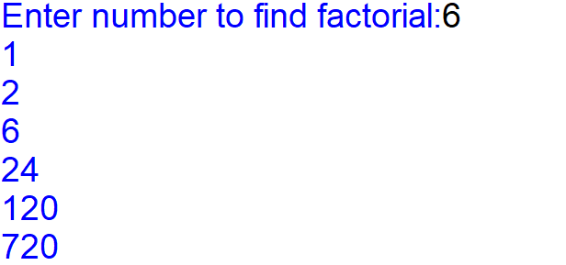

4.INPUT:

#To find largest element in a list

def inputlist():

a=list()

l = int(input("LIMIT:"))

for i in range(l):

item = int(input("ENTER ITEM TO ADD TO LIST:"))

a.append(item)

return a

def maxOfList(l):

max = l[0]

for i in range(len(l)):

if l[i]>max:

max = l[i]

print("largest element in list is :",max)

maxOfList(inputlist())

OUTPUT:

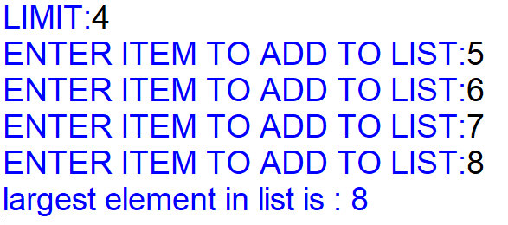

5.INPUT:

#To check if a string is palindrome using function

def pali(word):

w = word.upper()

if w == w[::-1]:

print(word,"is a palindrome")

else:

print(word,"is not palindrome")

inp = input("Enter a word to check if palindrome:")

pali(inp)

OUTPUT:



6.INPUT:

#Find sum of elements in a list using function

def sum(l):

s = 0

for i in l:

s += i

return s

ls = list()

n = int(input("Enter Limit:"))

for i in range(n):

item = int(input("Enter Number:"))

ls.append(item)

print("sum of elements:",sum(ls))

OUTPUT:

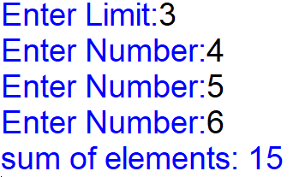

7.INPUT:

#To print nfibonacci series using function

def fibo(n):

n1,n2,n3,i=0,1,0,0

print("Fibonacci series")

while i<n:

print(n1)

sum=n1+n2

n1=n2

n2=sum

i += 1

n=int(input("enter required number of terms"))

fibo(n)

OUTPUT:

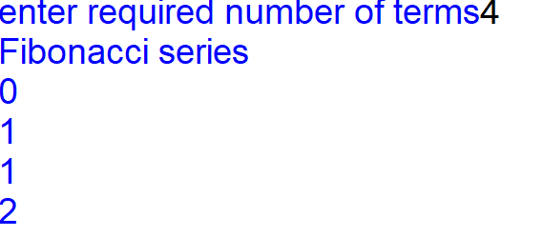

8.INPUT:

#to add 3 numbers using function(use default argument)

def sum(a,b=10,c=25):

print(a+b+c)

sum(b=23,c=90,a=5)

sum(45,c=34,b=25)

sum(54,654,64)

sum(687,c=43)

sum(57,b=5)

sum(54,23)

sum(5)

OUTPUT:

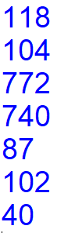

9.INPUT:

#linear search

n=int(input("limit:"))

l=[]

for i in range(n):

item=eval(input("enter number:"))

l.append(item)

p=eval(input("enter no to search:"))

pos=-(len(l)+1)

poss = pos

for i in range(n):

if l[i]==p:

pos=i

if pos==poss:

print("item not found")

else:

print("\nITEM FOUND AT\nindex:",pos,"\nand position",pos+1)

OUTPUT:

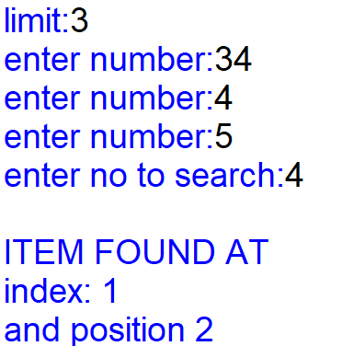

10.INPUT:

#To find largest of 2 numbers using function

def lORs(num1,num2):

if(num1>num2):

print(num1,"is greater than",num2)

elif(num1<num2):

print(num1,"is less than",num2)

else:

print(num1,"is equal to",num2)

n1= eval(input("enter a number"))

n2=eval(input("enter another number"))

lORs(n1,n2)

OUTPUT:

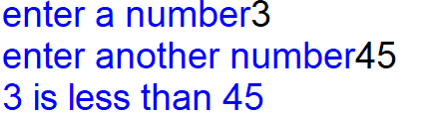

11.INPUT:

#to generate random numbers between 1&6(simulates a dice)

import random

def dice():

r=random.randint(1,6)

print("your dice rolled",r)

print("enter 'dice' to roll the dice")

while True:

a = input()

if a == "dice":

dice()

OUTPUT:

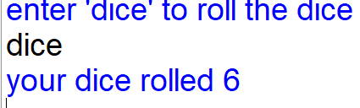

12.INPUT:

#Implement stack as a list

import time

s = []

while True:

print("1 : PUSH\n2 : POP\n3 : DISPLAY\n4 : PEEK\n0 : EXIT")

ch = int(input("ENTER YOUR CHOICE:"))

if ch == 0:

print("Closing program in 2 seconds")

print(2)

time.sleep(1)

print(1)

time.sleep(1)

print("0\nProgram Closed")

break

elif ch == 1:

item = int(input("ITEM TO PUSH:"))

s.append(item)

print(item,"pushed to stack")

elif ch == 2:

if s == []:

print("EMPTY STACK")

else:

print("DELETED ITEM:",s.pop())

elif ch == 3:

if s == []:

print("EMPTY STACK")

else:

l = len(s)

print("(TOP)",s[-1], end="")

for i in range(l-2,-1,-1):

print("<===",end=str(s[i]))

print()

elif ch == 4:

if s == []:

print("EMPTY STACK")

else:

print("TOP ITEM:",s[-1])

else:

print("!!!!!!!! INVALID SELECTION !!!!!!!!")

print()

OUTPUT:

